Unit 04 Problem Set Submission Form

# Overview

|  |  |
| --- | --- |
| Your Name | Rutwik Ghag |
| Your SU Email | rughag@syr.edu |

# Instructions

Put your name and SU email at the top. Answer these questions all from the lab. When asked to include screenshots, please follow the screen shot guidelines from the first lab.

Remember as you complete the problem sets it is not only about getting it right / correct. We will discuss the answers in class so it’s important to articulate anything you would like to contribute to the discussion in your answer:

* If you feel the question is vague, include any assumptions you've made.
* If you feel the answer requires interpretation or justification provide it.
* If you do not know the answer to the question, articulate what you tried and how you are stuck.

This how you receive credit for answering questions which might not be correct.

# Questions

Answer these questions using the problem set submission template. You will need to consult the logical model in the overview section for details. For any screenshots provided, please follow the guidelines for submitting a screenshot.

Write the following as SQL queries. If the query is ambiguous, fill in the games and justify your reasoning. For each, include the SQL as a screenshot with the output of the query.

1. Sales would like to send mailings to users who live in a zip code that starts with “13” for example 13244 so that can be notified of their new contact in that region.

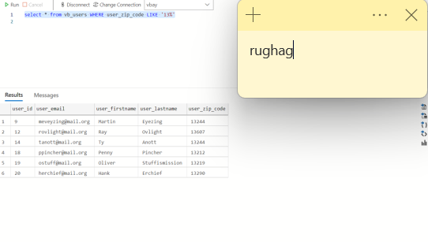

1. Find all the users from the state of New York. print their names and emails along with their city, state and zip code. Sort by city, then user’s last /first name.

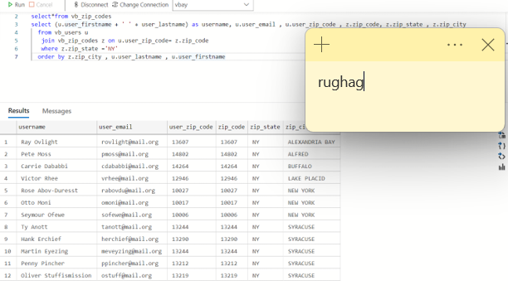

1. High Priced Items. Return the id, name, type, and reserve of items which have not been sold and have a reserve of 250 or higher. Sort the output so that the largest reserve items are first.

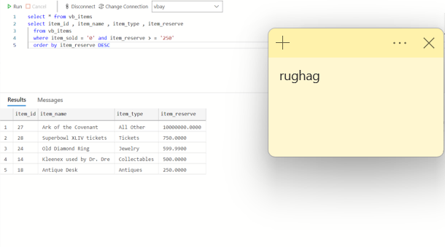

1. Reserve item categories. Include the id, name, type and reserve price of the item. Do not include items of type “All Other”. Create a category column based on item reserve price.  
   When the item is 250 or more it is a high priced item.   
   When the item is 50 or less it is a low priced item.  
   Everything else is an average priced item.

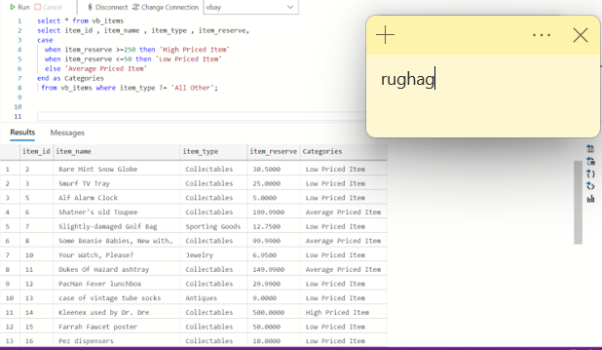

1. Bidder list. Write a query which displays the valid user bids (bid status of ‘ok’) for a given item_id. This would commonly be displayed on the website for the chosen item. You select the item id to display and show the bid id, bid user’s name, bid user email, bid date, and bid amount. Put the most recent bids at the top.

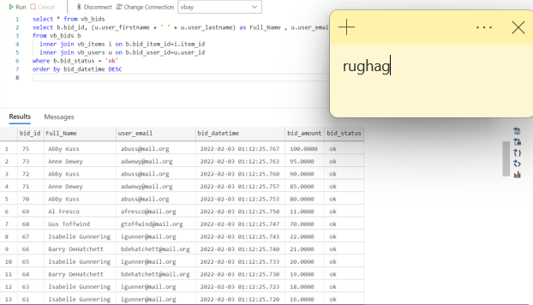

1. The bad bidder list. Write query to help the security audit team find fraudulent activity. For any bid that does not have a status of ‘ok’, include the date of the bid, name, email and id of the bidder and the name and id of the item bid upon. Also include the amount of the bid and bid status. Sort the output by the user name (last, then first) and then by bid date for users with multiple bad bids.

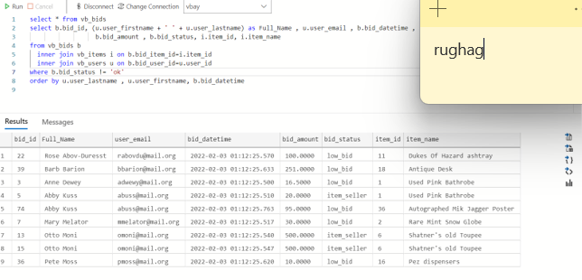

1. Produce a report of items which do not contain a bid. Include the item id, item name, item type, sellers name item reserve.

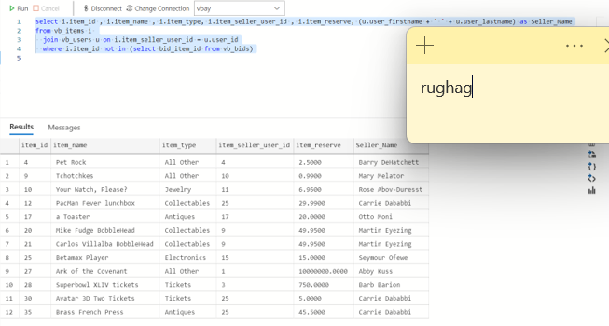

1. Produce a list of seller ratings. Include the name of the user who gave the rating, the name of the user the rating was for, the rating value, and rating comment. Include only ratings of sellers.

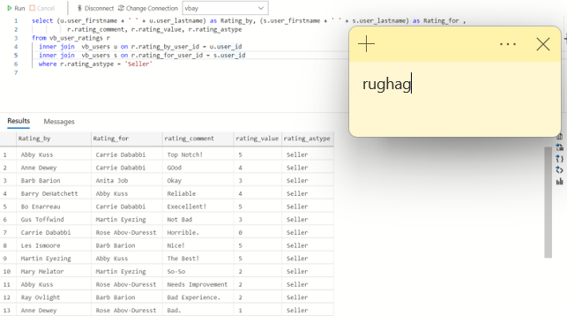

1. For items that were sold, generate a report which includes the locations (City and state) of the buyer and seller. Include item id, item name, item type item sold amount name of seller, seller’s city/state, name of buyer, and the buyer’s city /state

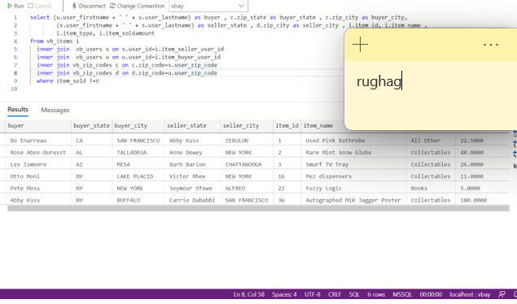

1. Users with no activity. Find the names and emails of any users who have never posted an item for bid or have never bought the item or have never placed a bid.

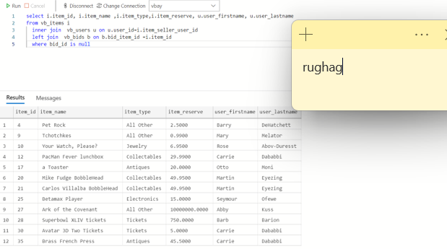

# Reflection

Use this section to reflect on your learning. To achieve the highest grade on the assignment you must be as descriptive and personal as possible with your reflection.

1. What are the key things you learned through the process of completing this assignment?

I learned how to joins work on tables using the various join commands and the select statements. I also understood the flow of writing and processing the queries. I also learnt how to implement conditional statements using the case, when and else commands. Lastly, I understood how to identify which table has to be referred and joined by the required parameter.

1. What were the challenges or roadblocks (if any) you encountered on the way to completing it?

This assignment was slightly challenging due to the requirements of select statements and joining tables in a database. Watching the video and practicing the walk-through helped in completing this assignment.

1. Were you prepared for this assignment? What can you do to be better prepared?

I may have been better prepared if I had a little more practice with writing queries. Forming queries is new to me.

1. Now that you have completed the assignment rate your comfort level with this week’s material. This should be an honest assessment: (choose one)

4 ==> I understand this material and can explain it to others.